„Grandma and Grandpa are very nice” - rhyme

Grandma and Grandpa are very nice
Like presents and candies, and strawberry ice
In summer and winter, in rai nor in sun
Grandma and Grandpa are wonderful fun.

Colouring page – kolorowanka

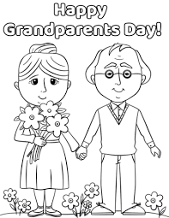
Grandparents song

https://www.youtube.com/watch?v=I_qUVEUZyTU

